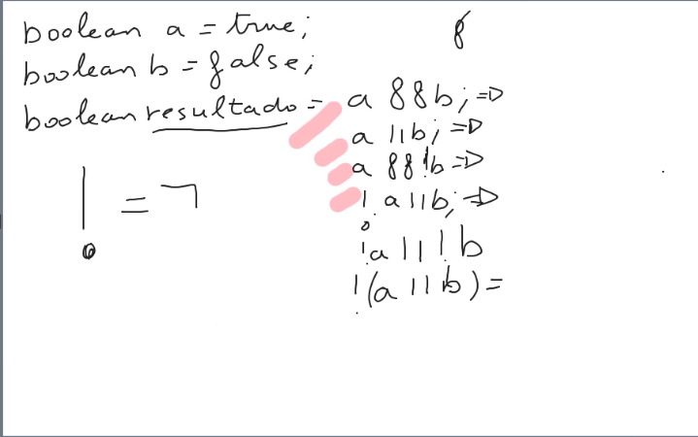
Conjuncion y disyunción

1,false
2,true
3,true
4,false
5,true
6,false

!(!a||!b); → false.

---------------------------------------------------------------------------------------------------------------------
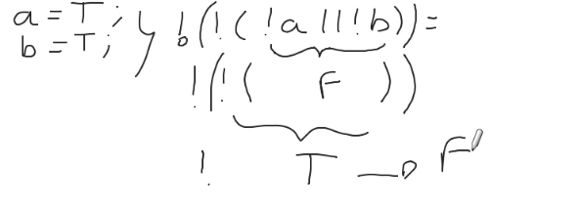

-----------------------------------------------------------------------------------------------------------------------

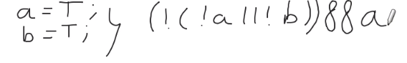
True
----------------------------------------------------------------------------------------------------------------------
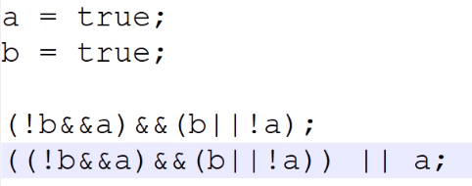
1, False
2, True

